AN MINI PROJECT REPORT

on

Logistics App

Department of Computer Engineering & Applications
Institute of Engineering & Technology

Team Members
Gagan Saxena(161500210)
Rajeev Pachauri(161500433)
Prakhar Shrivastava(161500392)
Siddhant Bansal(161500557)



GLA University
Mathura- 281406, INDIA

Department of Computer Engineering and Applications
GLA University, Mathura
17 km. Stone NH#2, Mathura-Delhi Road, P.O. - Chaumuhan,
Mathura-281406

DECLARATION

I hereby declare that the work which is being presented in the Mini Project-1 Report “Logistics App”, In partial fulfillment of the requirements for Mini Project-1 is an authentic record of my own work carried under the supervision of Mr. Neeraj Khanna Sir, Assistant Professor, GLA University, Mathura

Sign._____________________

Acknowledgment

We are extremely grateful to Mr.Neeraj Khanna for his revered guidance and encouragement, which led to the completion of this project till now. Without his constant appraisal and efforts, this task would have been a mere dream. He was always there to help us throughout this project. He provided us with all the necessary resources and guidance during the project which helped us to complete the project successfully. Finally, we deem it a great pleasure to thank one and all, which helped us directly or indirectly in carrying out this term paper project work. We are also thankful to our colleagues and friends for their support. On a personal note, we owe everything to the almighty and our parents. We would also like to thank our parents & other family members whose constant support & motivation helped us to complete the project successfully.

Table of Contents
1. Introduction 4
1.1 Purpose 4
1.2 Scope 4
1.3 Definitions 6-7
1.4 Acronyms, and Abbreviations 8
2. General Description 9
2.1 Product Perspective 9
2.2 Product Functions 9
2.3 User Characteristics 9
2.4 General Constraints 10

3. Specific Requirements 11
3.1 Use Cases 11
3.1.1 Use Case #1 11-12
3.2 Classes / Objects 13
3.2.1 Class / Object #1 13
3.3 Non-Functional Requirements 14
3.3.1 Performance 14
3.3.2 Reliability 14
3.3.3 Availability 14
3.3.4 Security 15
3.3.5 Maintainability 15
3.3.6 Portability 15
4. Analysis Models 16
4.1 Sequence Diagrams 16
4. 2Data Flow Diagrams (DFD) 17
4. 3Proposed Modules 18
5. Database Design 19
5.1Firebase Database 19
5.2Realtime Database 19
5. 3Firabse Authentication 20
6. Implementation and user interface 21
6.1intoducing layout 21
6.2Different ui widgets 21
7. Appendices 22-25
8.conclusion 26
9.References and bibliography 26
1.Introduction
1.1 Purpose
It is a type Android based Application which is related to Transport service. It is created specifically for distribution companies and delivery services. With this app, effortlessly manage your shipment, vehicles, and drivers. What's more, with automated email/SMS notifications and full mobile support, your logistical operations are guaranteed to be smooth. It is an app like in which you can search for nearby transport service or vehicles. In this app, you can book vehicle by seen the details of driver and vehicle details also.

1.2 Scope

- View the list of orders and detailed information on each.
- Track and evaluate delivery progress.
- Observe orders and estimated routes on the map.
- Receive push-notifications on relevant events related orders, routes, and delivery process.
- Make a detailed route to an order using external navigational applications.

1.3 Some important definitions
- Android studio: Android Studio is the officially integrated development environment (IDE) for Google's Android operating system, built on Jet Brains' IntelliJ IDEA software and designed specifically for Android development. It is available for download on Windows, macOS and Linux based operating systems.

- Firebase: Firebase is a mobile and web application development platform developed by Firebase, Inc. in 2011, then acquired by Google in 2014.

- Application server: An application server is a software framework that provides both facilities to create web applications and a server environment to run them. An application server acts as a set of components accessible to the software developer through a standard API defined for the platform itself.

- API: API stands for application program interface. A programmer writing an application program can make a request to the Operating System using API (using graphical user interface or command interface). It is a set of routines, protocols and tools for building software and applications.

- App:App is an abbreviated form of the word "application". An application is a software program that is designed to a specific function directly for the user which can be access easily.

- Android:Android is an open source operating System for mobile devices such as smart-phones and tablet, computers. Android offers a unified approach to application development for mobile devices which means developers need to develop only for Android, and their applications should be able to run on different devices powered by android.

- Android was developed by the Open Handset Alliance(OHA) , led by Google, and other companies. Android is mainly based on direct manipulation ,using touch gestures that looses correspond to real world actions. It provide us with the manipulate on-screen object, along with a virtual keyboard for text input.

- History of Android :Android was initially developed by Android Inc. Founded by Andy Rubin in Palo Alto, California, United States in Oct 2003. Android was named after the nickname of Andy Rubin by their co-workers for his love for robot. Google acquired android Incorporation on 17th Aug,2005.In 2010,Google launched it’s Nexus series of devices in smart-phone world with android OS.

- Android Version:
  - Android 1.0, 1.1(Apple Pie,Base_1_1)

  - Android 1.5(Cupcake)

  - Android 1.6(Donut)

  - Android 2.0(Eclair)

  - Android 2.0.1(Eclair_0_1)

  - Android 2.1.x(Eclair_MR1)

  - Android 2.2.x(Froyo)

  - Android 2.3 - 2.3.2(Gingerbread)

  - Android 2.3.3 - 2.3.4(Gingerbread_MR1)

  - Android 3.0.x, 3.1.x, 3.2(HoneyComb, HC _MR1, HC_Mr2)

  - Android4.0 - 4.0.2, 4.0.3 - 4.0.4((Ice_Cream_Sandwich,ICS_MR1)

  - Android 4.1 - 4.1.1, 4.2 - 4.2.2,4.3(JellyBean, JB_MR1, JB_MR2)

  - Android 4.4, 4.4W (Kitkat, KWatch)

  - Android 5.0, 5.1(Lollipop, L_MR1)

  - Android 6.0 (Marshmallow)

  - Android 7.0 (Nougat)

  - Android 8.0 (Oreo)

1.4 Some Acronyms
- API - Application Program Interface
- App - Application

2. General Description

2.1 Product Perspective
The Logistics application is independent and self-contained. An integrated data base will ensure the storage and the retrieval of the user related information. It will be the product that help different sections of society and bring solution under one roof.

2.2 Product Functions
- Register – The user must register once in order to get access to the application; after registering, a unique user name and password will be provided and will allow the logging in of the registered user.
- Log-in – A registered user has to enter his/her unique user name/password combination in order access the application.
- Booking – You can Book the transport for pickup and delivery of goods and services.
- Log-out – User logs out in order to let another user to register or log-in.
- Exit – User exits the program.

2.3 User Characteristics
- Types of Users
- Customer
- Driver
- Administrator
- Technical expertise: All users needs to have minimal technical expertise (need to know the use of Android Operated smart phone)

2.4 Constraints
- Platform: One must work on Android Operating System
- Operating system: For Android: One must have Jellybean or above.
- Hardware: The Mobile must have 128 MB of RAM minimum 800x600 screen resolution with 256 colors.
- GUI is only in English.
- Login and password is used for the identification of users.
- Limited to HTTP/HTTPS.
- This system is working for single server.

3. Specific Requirements
3.1 Use Cases
3.1.1 Use Case #1
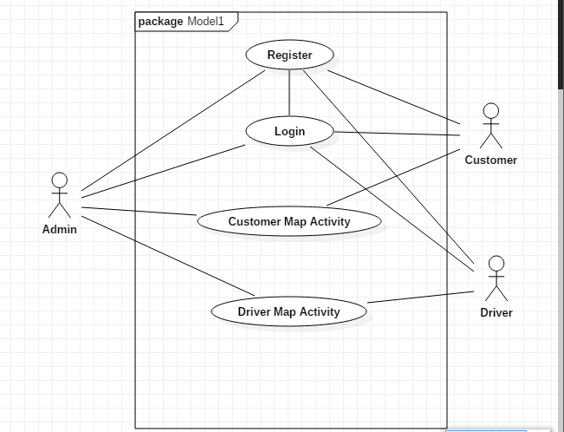
Fig. 3.1 Use Case Diagram of Logistics App
Admin: The admin is responsible for the new updates and the overall working of the application. The admin also manages the database features and the functionality provided to the user and provides the best experience to the user. Admin also login to make applied changes.
Customer : In this application customer can login and also book their ride and take their luggage from one place to another and this application help user to save their time rather then to waste their time to find the loader.

Driver : In this application Driver can login and also check customer location. Where, They have to reach and provide the service to the customer.
3.3 Software System Attributes
3.3.1 Reliability
The system will not crash on invalid data files or input files. If video files are uploaded in a format that is not recognized, the system will ask the user to recode the file in the correct format or the system will produce an error (refer to section 3.5.4 Maintainability for adding data files). The data files will be stored on a nonvolatile storage device such as a hard drive(basically sever), so that the data files can be retained when the system is shut off. The system will check the validity of the user files when they are loaded. If there is an error the system will ask the user to check his/her account. If there is a fatal error the system shuts down without crashing the system it is running on.
3.3.2 Availability
The system will only run infrequently. The system will allow the user to restart the application after a crash. All data beyond the last save point will be lost. The user will be able to load his or her data file after the system has been restarted and continue using the system. The system will have an average run time of 15 to 20 min per session(it can be modified by the admin on consult) depending on the user, although the user may use the system longer.

3.3.3 Security
The system will use the computer’s default operating system security. The system will not use any of its own security features since the software is not web-based and it is going to be run over a network. The system will be contained on one android biased operating system. The data files will be encrypted since the data stored in firebase is sent in an encrypted format. The system checks the validity of the data files when it is running and if the data is invalid the system outputs an error to the user. The system will not keep log files of the User’s usage.

3.3.4 Maintainability
The admin will be able to update the system with new features and updates. The system will ask the user to specify the videos, audios, photo, will be stored to the database. To add a video, photo (image) it must be put in this directory and there must be a corresponding data file for the video, image. The corresponding data file will contain information about the complaint in the form of text, image, video and audio where the user can put this along with information of complain. The product will be built using components that are as independent as possible to make the system easily modifiable. All components of the system will be modular and be as independent as possible. Each component will have a different function, GUI. Users will be able to add new content with each complaint. The system will allow the higher authority to be notified about the problem faced by the individual in the campus.

3.3.5 Portability
The product will be able to run on Android Operating system. The software will be written in a platform independent programming language for portability; there will be no platform specific code. We will write all the software using Java. All the video files will be in mp4 and above format that can be played back on android operating system. We will use the android Media Framework for support of the playback of video files. The system’s data files will be portable for android operating system. The user will have to install the required application on the system. The system will also require that the Android Runtime Environment (ART) with latest version.

4. Analysis Models
4.1 Sequence Diagrams
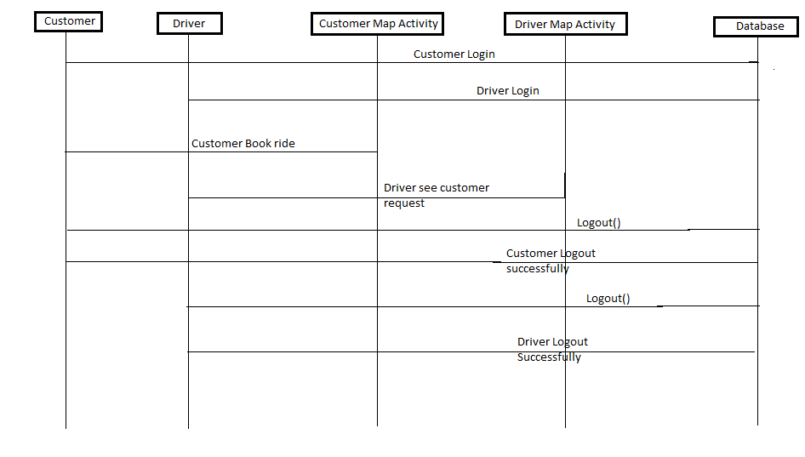

Fig.4.1 Sequence Diagram of Logistics App
Customer : In this application customer can login and also book their ride and take their luggage from one place to another and this application help user to save their time rather then to waste their time to find the loader.

Driver : In this application Driver can login and also check customer location. Where, They have to reach and provide the service to the customer.

4. 2Data Flow Diagrams (DFD)

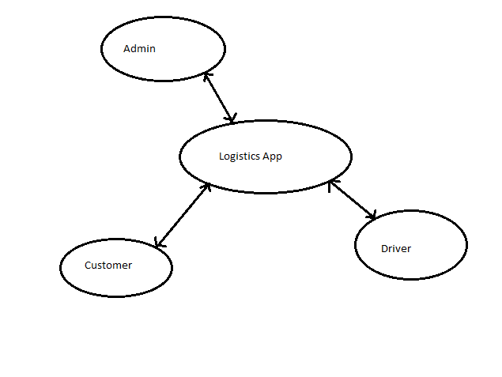
Fig.4.2 DFD Diagram of Logistics App

5. Database Design :
5.1 Firebase Database
Firebase is a mobile and web app development platform that provides developers with a plethora of tools and services to help them develop high-quality apps, grow their user base, and earn more profit.

5.2 Realtime Database
The Firebase Realtime Database is a cloud-hosted NoSQL database that lets you store and sync between your users in realtime. The Realtime Database is really just one big JSON object that the developers can manage in realtime.
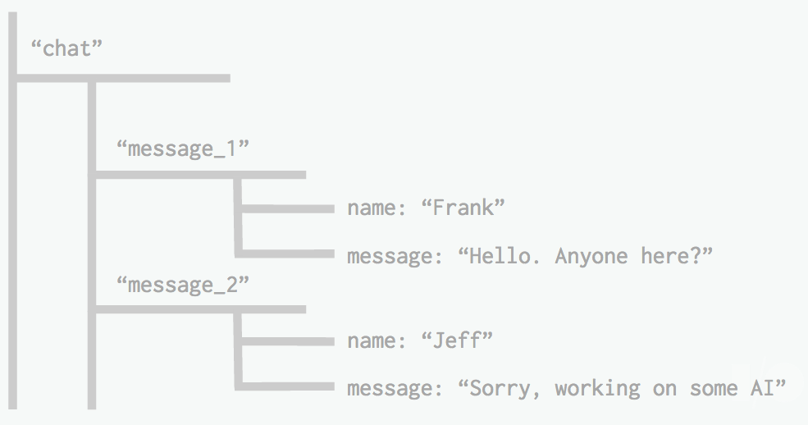
Fig 5.1 Realtime Database Design
With just a single API, the Firebase database provides your app with both the current value of the data and any updates to that data.Realtime syncing makes it easy for your users to access their data from any device, be it web or mobile. Realtime Database also helps your users collaborate with one another.
The Realtime Database can also integrate with Firebase Authentication to provide a simple and intuitive authentication process.
5.3 Authentication:
Firebase Authentication provides backend services, easy-to-use SDKs, and ready-made UI libraries to authenticate users to your app.
Normally, it would take you months to set up your own authentication system. And even after that, you would need to keep a dedicated team to maintain that system. But if you use Firebase, you can set up the entire system in under 10 lines of code that will handle everything for you, including complex operations like account merging.
Using Firebase Authentication makes building secure authentication systems easier, while also improving the sign-in and onboarding experience for end users.
Firebase Authentication is built by the same people who created Google Sign-in, Smart Lock, and Chrome Password Manager.

6.Implementation and User Interface:
  - Introducing Layout :
- Linear Layout
Linear Layout is a view group that aligns all children in a single direction, vertically or horizontally. You can specify the layout direction with the android:oriantation attribute.
All children of a Linear Layout are stacked one after the other, so a vertical list will only have one child per row, no matter how wide they are, and a horizontal list will only be one row high (the height of the tallest child, plus padding). A Linear Layout respects margins between children and the gravity (right, center, or left alignment) of each child.
- Relative Layout
Relative Layout is a view group that displays child views in relative positions. The position of each view can be specified as relative to sibling elements (such as to the left-of or below another view) or in positions relative to the parent Relative Layout area (such as aligned to the bottom, left or center).
A Relative Layout is a very powerful utility for designing a user interface because it can eliminate nested view groups and keep your layout hierarchy flat, which improves
performance. If you find yourself using several nested Linear Layout groups, you may be able to replace them with a single Relative Layout.
6.2 Different UI widgets available in Android :
- Text View
- Edit Text
- List View
- Spinner
- Button

7. Appendices
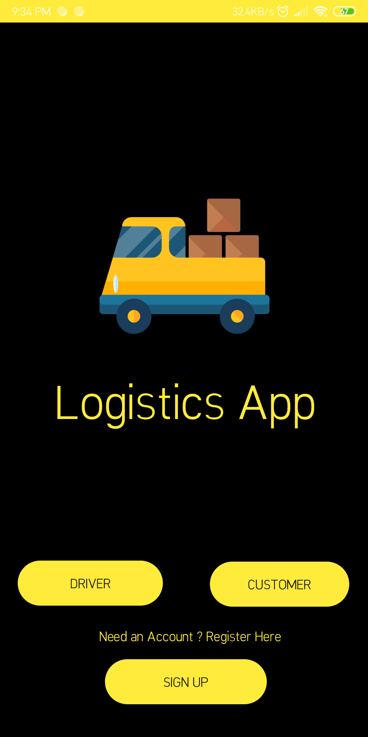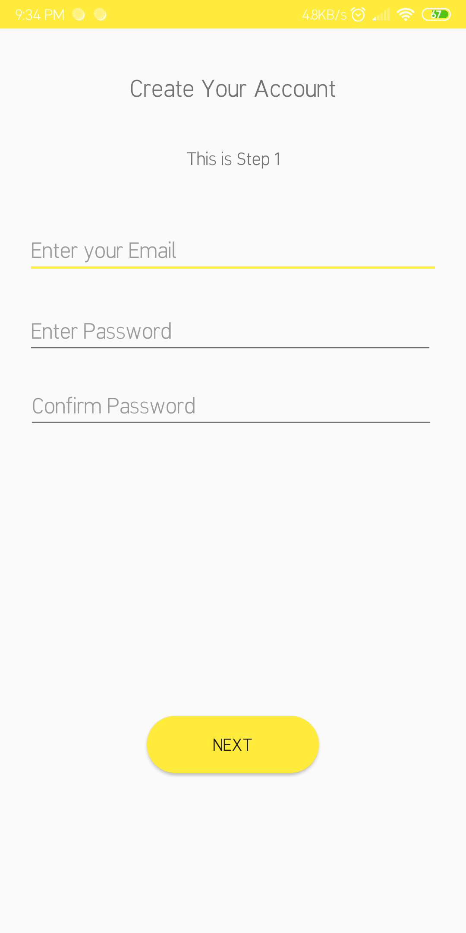
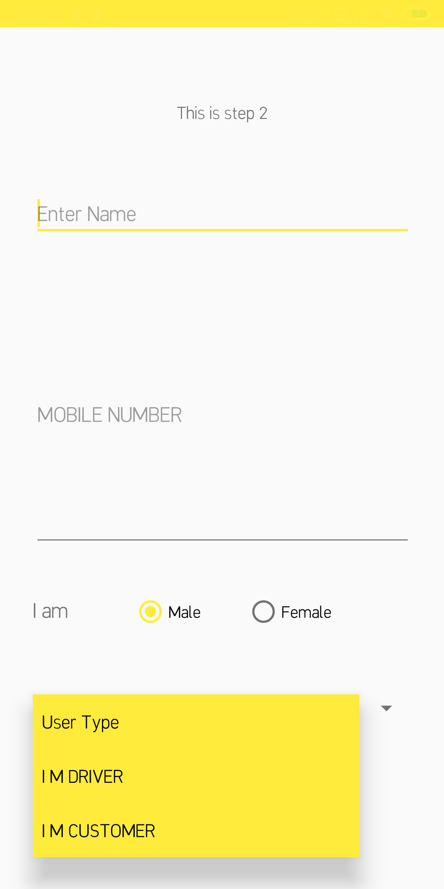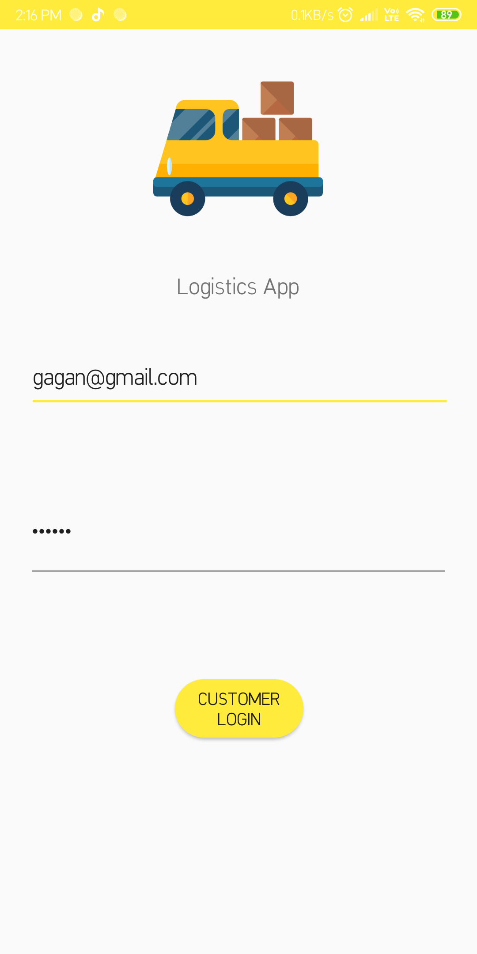
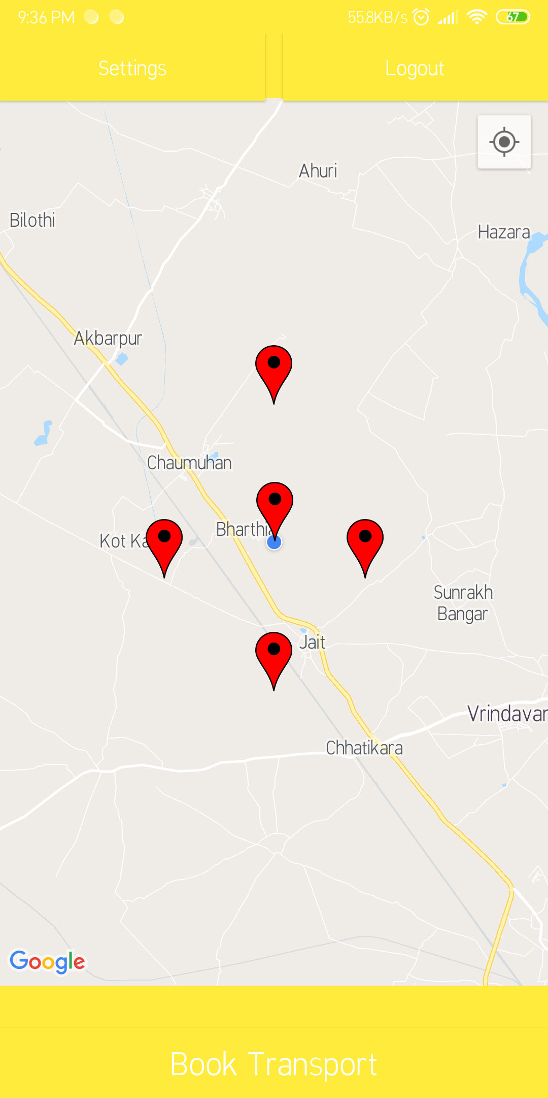
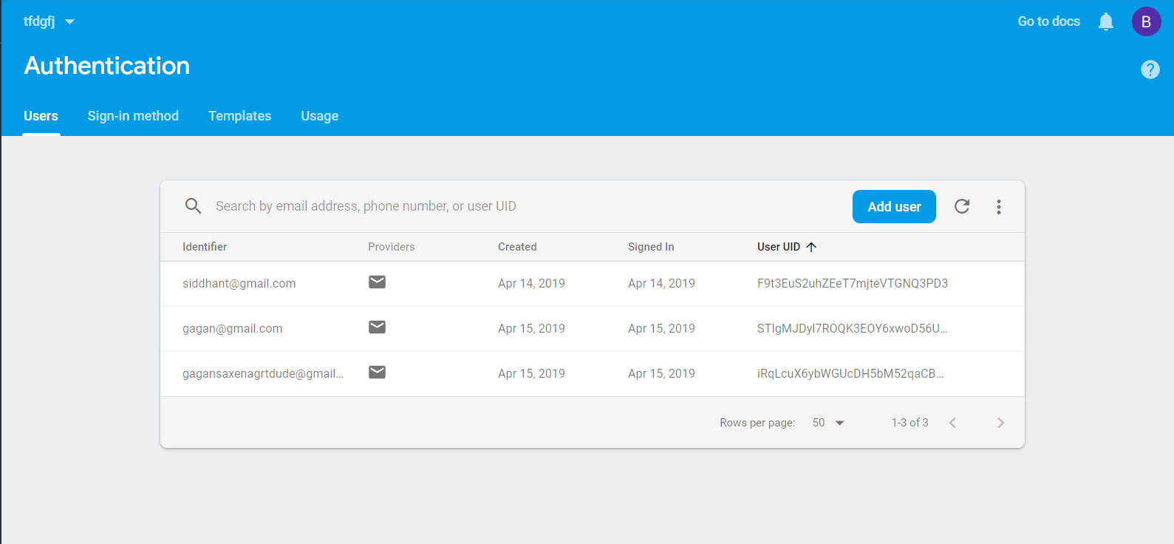
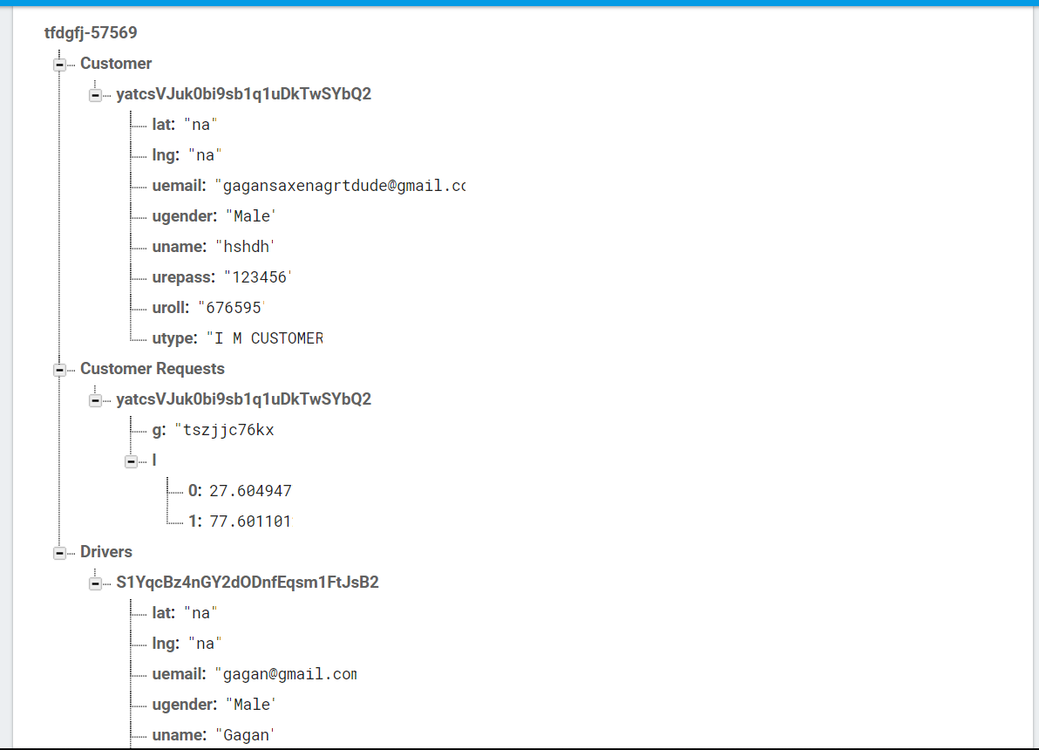

8. Conclusion:
The entire project has been developed and deployed as per the requirements stated by the user. Finally, we like to conclude that we put all our efforts throughout the development of our project and tired to fulfill most of the requirements of the user.

9. References/Bibliography:
Following are the links from which all the information have been taken :
- https://developer.android.com/training/basics/index.html
- https://developer.android.com/training/basics/concept/creating-project.html
- http://www.hiddenbrains.com/android-application-development.html
- https://www.tutorialspoint.com/android/

